**Pardot Specialist Study Guide**

*January 2019*

**Email Reputation and Deliverability Glossary**.

Abuse Complaint

When prospects mark an email as spam in their email client. These spam complaints are recorded in Pardot and appear in your spam-complaint reporting. The limit for abuse complaints is one per every thousand emails, or 0.1%.

Bounce Code

A bounce code is a reply from the recipient’s mail server that describes why an email wasn’t delivered. Mail server administrators can customize the messages that accompany codes, so messages can be different from server to server. Pardot doesn’t generate bounce codes, so contact the recipient’s mail server administrator if you need clarification about a message.

Blacklist

A list of IPs or domains that are sending unsolicited email and engaging in email bad practices. Blacklists can be public or private.

CAN-SPAM

The U.S. law that sets the rules and requirements for senders of bulk marketing email within the United States. When editing Tracking Opt In Preferences you can edit the style and position of the banner and which countries you request opt in for

CASL

The Canadian anti-spam legislation that sets the rules and regulations for senders of bulk marketing email to or from Canada.

Dedicated Sending IP Address

A dedicated sending IP address gives you full control of your email sending, so you are entirely responsible for the reputation of your own IP address. A dedicated IP service is best for clients sending a consistently high volume of emails. Shared IP addresses are best for lower-volume or inconsistent senders. A dedicated IP address gives you more control over your sending reputation. On a shared IP address, the sending practices of others affects all senders on the address.

In industries with heightened security, like banking and defense, a dedicated sending IP address is more likely to be whitelisted than a shared address. When your sending IP address is whitelisted, your emails are more likely to stay out of the spam folder.

Direct complaint

When subscribers complain that they no longer want to receive email from you by emailing our abuse@pardot.com address. These cases are different from standard abuse complaints, because Pardot gets a direct email from the complaining prospect.

DomainKey

Verifies the domain of an email sender and message integrity to prevent email tampering. DomainKeys are like signing the back of an envelope to prove that the message inside has not been tampered with.

Engagement

How subscribers respond to the content you’re sending. Are your emails being opened and clicked through? Higher engagement metrics improve your reputation and deliverability. Lower engagement, including marking as spam, can decrease your reputation and deliverability.

ESP

Email service provider. ESPs enable a user to send permission-based marketing campaigns to prospects.

MTA

Message transfer agent. An application that transfers email from point A to B.

Permission-based marketing

The practice of sending marketing emails to only those recipients who have consented to receiving them. Pardot’s permission-based marketing policy means that every prospect in your account must give you explicit permission before you send them marketing emails.

Reputation

How your content and sending are judged. It’s a score (out of 100) tied to your IP address or domain that determines how trustworthy of a sender you are. Generally, reputation is calculated with a formula of engagement, abuse complaints, bounces, and send volume.

Spam

Unsolicited bulk email. Unsolicited means that the recipients have not explicitly consented to receiving emails from the sender. Bulk means that the message is sent as part of a larger collection of messages, all having nearly identical content.

SPF

Sender Policy Framework. An email validation system that prevents email spam by detecting email spoofing by verifying sender IP addresses.

Spamtrap

Bait email addresses that blacklisting providers and ISPs use for catching spammers. Spamtraps can be in old lists, purchased lists, and scraped lists, and they never opt in to receiving email. The best way to stay away from spamtraps is to use permission-based marketing and clean old lists before sending through

Pardot.

Tracker Domains

Tracker domains give your visitors a seamless transition between your hosted pages and forms and your Pardot assets. When you create marketing assets and email templates, you can choose which tracker domain you want to use for vanity URLs and link rewriting.

Transactional / Operational Email

An email meant to be used for important updates not related to marketing information. They do not require an unsubscribe link. Transactional emails include confirmations, reminders, or important system-wide updates.

Unsubscribe

When a prospect requests to be removed from a list. Unsubscribes must be honored in a timely manner. Failure to do so is a violation of CAN-SPAM.

SPF and Domain Key are necessary for email authentication

Good bounce rate is anything lower than 10%

Organizations that excel at Lead Nurturing sees 50% more sales at 33% lower cost.

On Lead Nurturing timing between emails ideally between 6 and 30 days.

HOW to avoid your email going into spam:

1. Text Version
2. Add domainkeys & SPF
3. Avoid spammy words
4. Check image to text ratio

**Recycle Bin:**

When you delete an asset, it’s moved to your recycle bin instead of being permanently deleted. You can restore most assets from the recycle bin. You can’t empty the recycle bin.

Items in the recycle bin don’t count toward usage limits.

If you delete a campaign, the prospects associated with the campaign remain in the system tagged with the deleted campaign. Before deleting, Pardot warns you if elements associated with the campaign, such as lists, rules, and landing pages, are in use. You can then delete the assets or associate them with another campaign.

Admins can permanently delete prospects in the recycle bin. Pardot no longer tracks prospects when they’re permanently deleted.

A deleted prospect is restored when the Salesforce record it’s syncing with is undeleted. When you permanently delete a prospect in Pardot, you must delete associated leads and contacts in Salesforce.

Tags are deleted permanently and don’t appear in the recycle bin.

Content files are permanently deleted and cannot be undeleted, but they are listed in the recycle bin**.**

**Engagement Studio**

If you remove a prospect from a program's recipient list, then add the prospect back later, they start where they left off in the program.

If a prospect is removed from a list that is being used for a program, that prospect stops moving through the program.

If a prospect opts out of a list used for a program, they still move through the program, but don’t receive program emails. If a prospect is on multiple lists feeding a program, the prospect receives emails unless they opt out of all lists feeding the program.

You can add prospects to a running engagement program regardless of the step other prospects have reached. Every time a new prospect is added to the engagement program’s recipient list, the new prospect starts at the beginning.

Prospects within each phase of the drip program will only populate once the phase is complete. There is not an option to see prospects "processing" through the phase.

You can use ‘email link clicks’ and ‘file downloads’ as triggers in an Engagement

To send a series of emails without checking for clicks or performing other actions, add Send Email actions without other triggers, actions, or rules.

You can add emails or steps to engagement programs at any time by editing the programs. However, prospects who have already progressed through edited steps don’t experience the changes retroactively. Prospects only experience edits to steps that haven’t started yet.

For best performance, limit your program to fewer than 300 steps.

Program steps don’t inherit settings from previous steps. For example, if your program includes a Send Email action followed by an Email Open trigger, you must select the email template in both steps.

Your edition determines how many engagement programs can run at one time.

Pardot Growth Edition: 20

Pardot Plus Edition: 100

Pardot Advanced Edition: 200

If your form is on a Pardot landing page, a form view or completion doesn’t satisfy a form trigger. Use a landing page trigger instead.

For any prospects that are on a step with a wait, the wait is paused when an engagement program is paused. The prospect remains on the step until the program is resumed. When the program resumes, the prospect will finish the wait before moving to the next step.

**Pardot Lists**

Dynamic lists update continuously

Static list membership can be amended

**Pardot Reports:**

What report will offer you insight into how your recipients read your emails? Engagement Report

What devices or browsers they use to view them? Email Client Report

Active Prospects for Review – assigned OR marked as reviewed that have been Active

Prospect Lifecycle – tells you marketing velocity of prospect

Form Reports includes:

-Total views

- total submissions

- submission rate

- total errors

- error rate

Email Report

-Total queued

-HTML Open rate

Total delivered = total sent – (hard + soft bounces)

If you use a Pardot form on a Pardot landing page, you should use the Pardot Landing Page Report to see form submissions

Visitors Report

The Visitors report displays the captured website sessions of anonymous visitors and identified prospects. You can filter sessions based on page views, campaign, and date range. To access the visitors report, navigate to Prospects | Visitors. Pardot retains an unlimited amount of web history for prospects and at least a year of data for anonymous visitors.

Identified visitors – filtering the table lets you view All visitors with identified companies

Pardot Campaign report – Cost per opportunity, cost per prospect, opportunities per prospect

**Pardot & SFDC Sync**

Lead or contact records must have a valid email address at the time they are created in salesforce.

Email address and Record ID tie together prospects to records in SFDC

You need a Salesforce Field Name in order to map a Pardot field to Salesforce

You can only have 1 salesforce connector at once

How to setup the Salesforce Connector: Install the Pardot AppExchange Package in Salesforce, Give SF users permission to access Pardot elements, Whitelist IP ranges, Add Salesforce to Pardot using Salesforce connector, map the fields, add Pardot fields to layout in SFDC, add Send to Pardot buttons, enable SSO

Pardot creates records in Salesforce as leads, but when the leads are converted into person accounts, Pardot syncs with the person account. Pardot doesn’t create more Salesforce leads for the synced prospect. With this syncing arrangement, a single Salesforce person account record syncs to two different records in Pardot: a prospect record and a prospect account record

**Pardot Prospects:**

‘Related’ tab of the Prospect record in Pardot shows prospects that have what in common: Email Domain

When a visitors converts, visits get carried across to a new prospect record

You can use Create / Associate to manually convert a visitor to a new or existing prospect

Visitors convert by:

-Submitting Pardot form iframed on your web page

-Submitting form on your site that is connected to Pardot form handler

-Clicking on tracked link from a Pardot email

On visitor record you can see:

-Number of visits

-Number of page views

-Hostname

Visitors Report

The Visitors report displays the captured website sessions of anonymous visitors and identified prospects. You can filter sessions based on page views, campaign, and date range. To access the visitors report, navigate to Prospects | Visitors. Pardot retains an unlimited amount of web history for prospects and at least a year of data for anonymous visitors.

Enable visitor filters for a specific IP range; enable send daily visitor activity emails in order to share a list of company names of all external visitors on their website.

Pardot starts you with a default profile but you may edit its criteria or create any additional profiles that meet your business needs. (**You cannot rename or delete the Default profile**.)

Default grade for all prospects is D

Required information when manually creating prospects:

-Email

-Full Name

-Score

-Profile

The value in a prospect’s source field is determined by the referring URL. The referring URL is the page the visitor was on prior to visiting a page with Pardot tracking code for the first time. Pardot pulls in source data when the referring URL is present and matches up with the expected website for a given vendor.

If you delete a Campaign, the prospects associated with that campaign: Remain in Pardot tagged with that Campaign

Merge Prospects - Duplicate prospects sometimes end up in your Pardot database. You can merge up to three prospects at once and select one to be master. When merged, the activities of the merged prospects are aggregated, and Pardot recalculates the master prospect’s score. Non-master prospects are permanently deleted and do not go to the recycle bin.

Prospect Table Actions - Apply mass actions to the prospect table without having to use an automation rule. You can select the entire table or individual prospects.

Ways to undelete a record in Pardot:

- If the deleted prospect re-converts by filling out a form with the same email address

- if the deleted prospect clicks a custom redirect

- if a deleted prospect downloads a non image file

- if the deleted prospect has an associated record in the CRM

**Prospect Scoring:**

Then HOW to adjust prospect scores:

1. Editing Baseline Scoring Rules (Admin > Automation Settings > Scoring Rules)
2. Completion Actions on Forms or Form Handlers
3. During Import
4. Manually from Prospect record

**Custom Redirects**

Pardot's custom redirects allow you to track any link on your website or a third party site (for example, a link your Twitter page, a banner ad on a third party site, etc.).

**Pardot Tracking Code**

Implement Tracking Code Pardot provides a General tracking code that is added to any page that you may want to monitor and any actions will be recorded for your analysis, much like any other popular web analytics tool.

**Processing Rules & Logic**

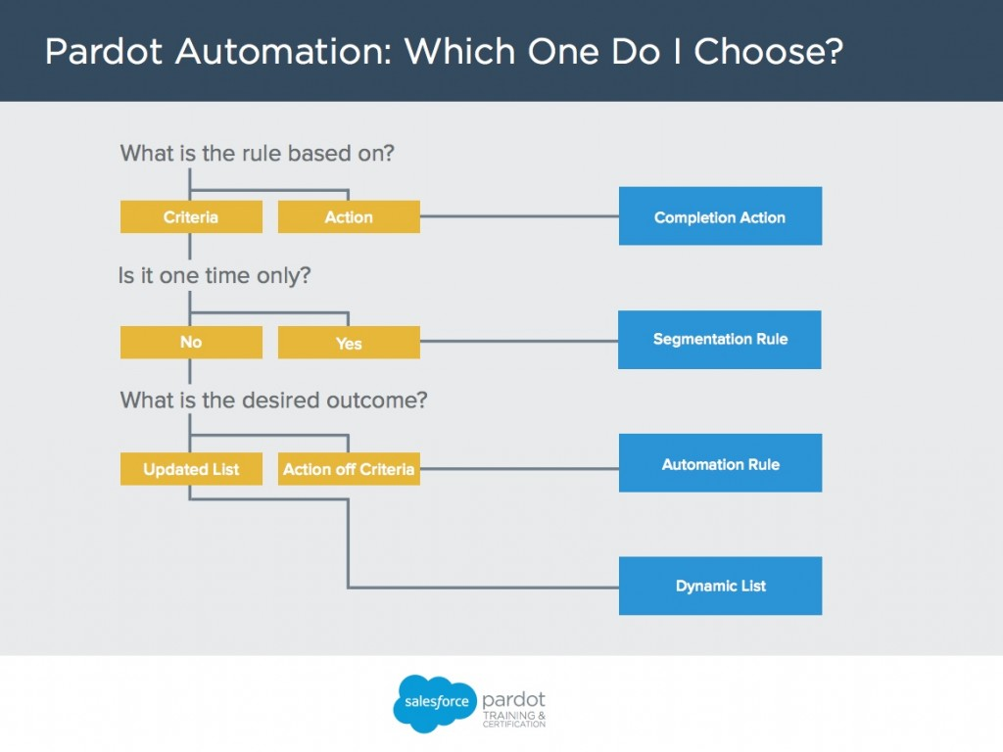

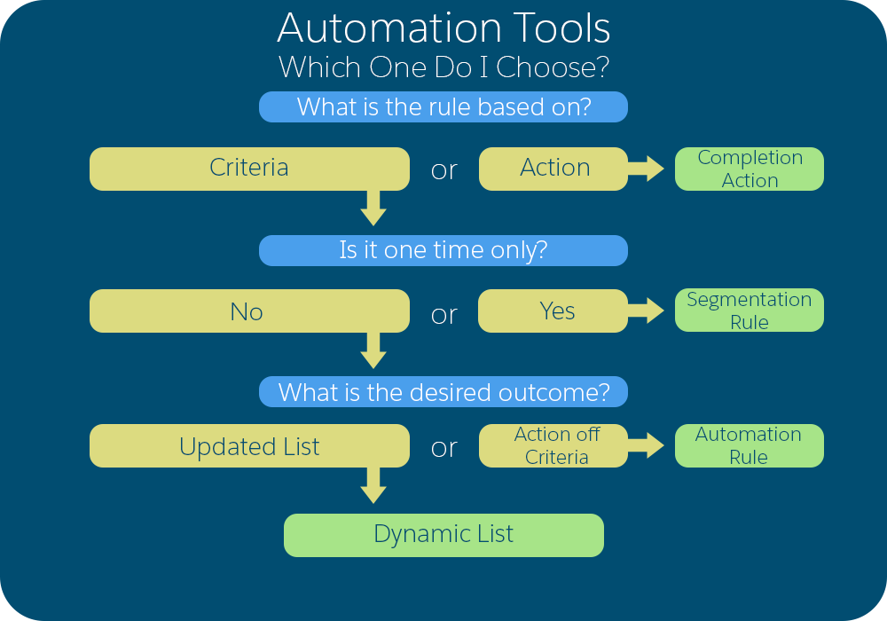

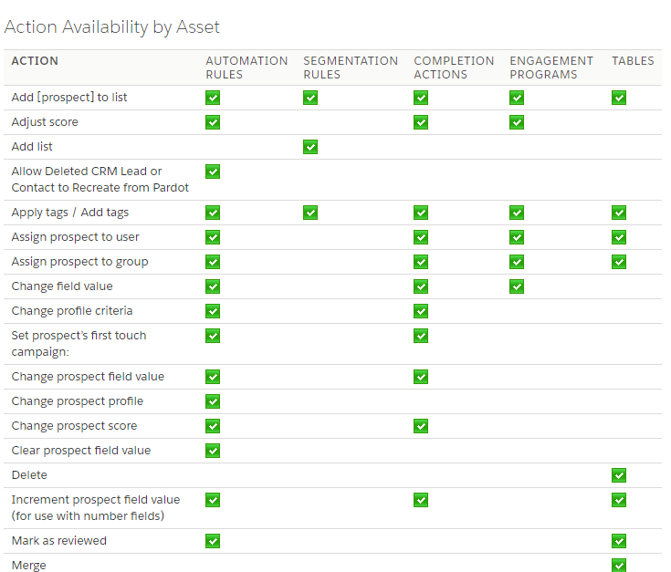

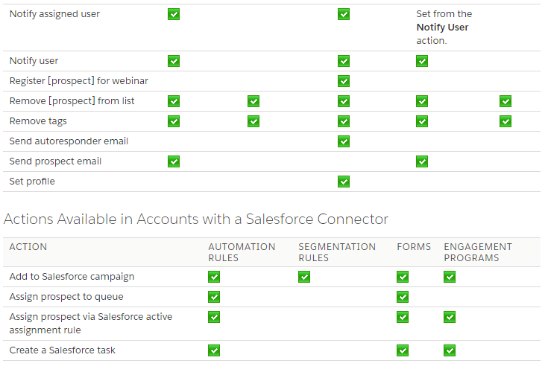

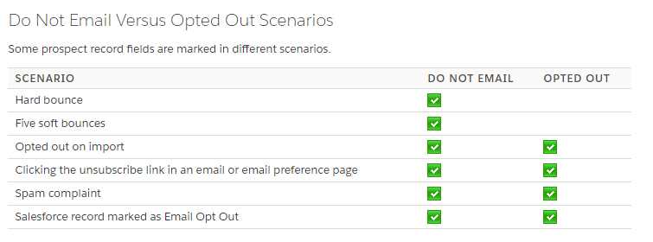

Keep these considerations in mind when using completion actions.

* Completion actions are not retroactive. They apply only to activities that happen after the completion action is added.
* Completion actions execute every time they are triggered. However, Adjust Score and Send Autoresponder Email are throttled.
* Completion actions execute only for prospects and don’t affect visitors.
* Completion actions don’t execute on image file downloads.
* Completion actions don’t execute on filtered activities.
* Completion actions based on link clicks don’t trigger on unsubscribe links or email preference page clicks.
* If you have multiple completion actions on a marketing asset, the actions that affect other automations run first. Next, the automation runs, then the rest of the completion actions run. For example, a form has these actions: assign to user, notify user, set custom field. Pardot assigns the prospect to the user first, then sets the custom field value, runs any real-time related automations, and then notifies the user

Completion actions can only be set for List Emails

Create an automation rule and use actions to decay score if you want to prevent prospects who have been inactive from being assigned in SFDC

A completion action assigns prospects based on a successful form submission, specific page view, file download, or a custom redirect click. Completion actions don’t reassign prospects who already have an owner

Completion actions can be used on PDF Files and Custom Redirects

Automations should be used when you want to run them more than once and when you want to run a real-time automation

Automations will never ‘un-match’ prospects if they no longer meet a rule’s criteria

An automation rule assigns your prospects based on complex criteria. The rule only assigns prospects who aren't assigned at the time they match the rule’ s criteria.

Automation rules will not reassign prospects who already have an owner, even if they meet the criteria for the rule. Assigning actions will assign "Reviewed" prospects.

Automations use: Match type, rule group, and action

Use segmentation rules to pull a one-time list from a Campaign several months after it launched

Page actions can be applied to a prospect who views a specific page of a website

**Landing Pages:**

Use multivariate testing to test which Landing Page versions are most successful

**Scoring**

Following activities can impact score: landing page errors, email opens, custom redirect clicks

Can edit the scoring model in Admin section or use completion actions with score impacts

Scoring is enabled by default

Changes to the baseline scoring model are applied: Retroactively; changes will be made for all prospect based on their past activities

**User Roles**

You can limit users ability to import prospects, export prospects, and send emails

The Administrator role is for “power users.” Users assigned this role can control broad account settings found within the Admin Module as well as campaign and prospect management functionality within the Marketing and Prospect modules. They can also view, edit, delete and import users.

The Marketing role is for users working primarily in the Marketing and Prospect Modules. They can manage prospects and create new lists, forms, landing pages, email templates and send list emails.

The Sales Manager role can view all prospects and visitors and associated reports. They do not, however, have any marketing functionality. Sales Managers may send individual emails but not list emails.

The Sales role has the simplest interface view in Pardot. Sales can view, edit and export prospects assigned to them only. Additionally, they can send individual emails to prospects, but not list emails.

**Pardot Connectors:**

You can connect Facebook, Twitter, and LinkedIn to Pardot

As many social media accounts can be linked per Pardot account as you want

You can track link clicks, replies, comments, retweets, and likes for social media connectors

AddThis Connector

Allows prospects to share content on their own social media accounts

|  |  |
| --- | --- |
| **Connector Category** | **Name** |
| **Webinar** | GoToWebinar  ReadyTalk  WebEx |
| **Social Posting** | Facebook  LinkedIn  Twitter |
| **Other** | bit.ly  Eventbrite  GoodData  Google Analytics  Olark  Twilio  UserVoice  Wistia |

**Salesforce Engage**

Salesforce Engage provides the exact insights you need at the right moment, empowering you to:

* effortlessly build tailored campaigns with marketing-curated content
* deliver a phenomenal buyer experience
* close deals faster

Lives within Salesforce, for access to sales reps and they can send emails from SF ‘engage emails’ accessing there within SF marketing approved content like templates already with all mail merge, the emails are actually sent from Pardot so all analytics are accessible such as opens, clicks etc